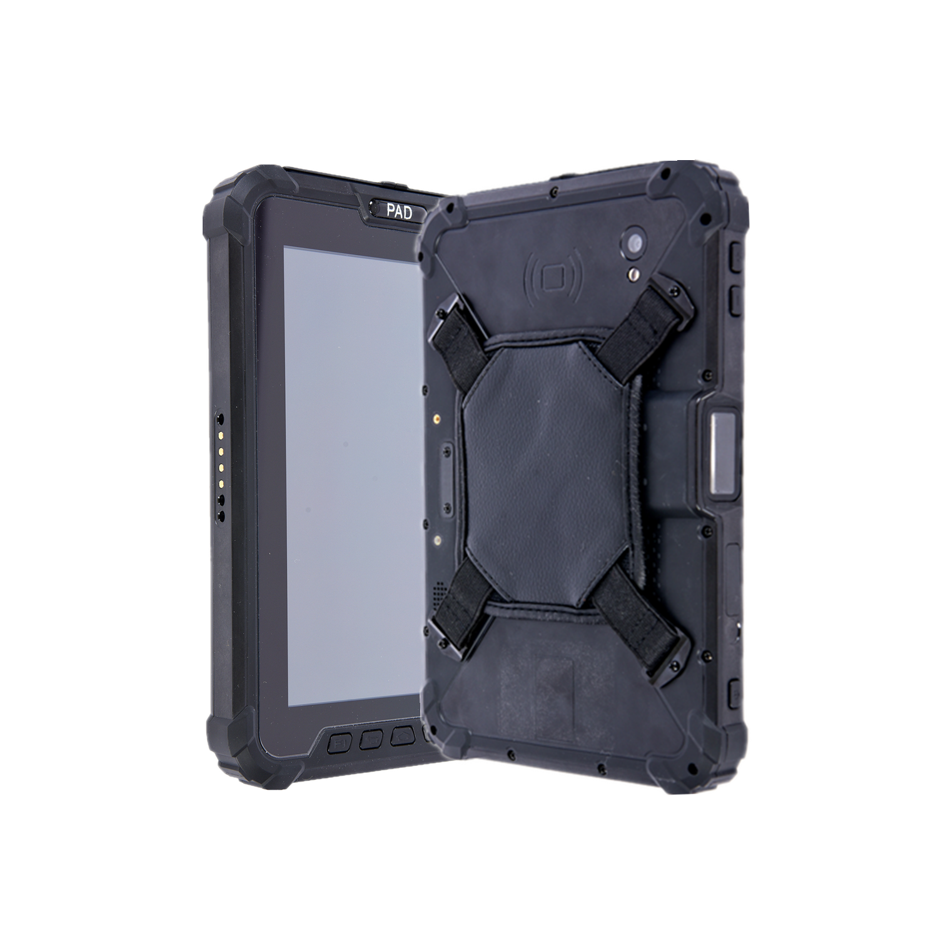


1

Recognize further
Endure longer
S917V10 with UHF module
Rugged Tablet PC

UHF module in V10

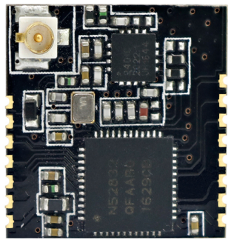
1
- Operating frequency band: 2.45GHz
- Chip: NRF52832
- Identification distance: 0-50m (adjustable)
- Recognition speed: 200km/h
- Antenna interface IPEX, external antenna can be connected
- Using hybrid data acquisition anti-collision algorithm
- Support active mode and passive mode
- Support real-time upload mode (default), scheduled upload mode and quantitative upload mode
Functional characteristics of UHF module

Serial port active module
This product is developed by a group of senior engineers with more than 10 years of rich working experience. It is a simple, easy-to-use, stable and cost-effective equipment.
It can be quickly integrated, and is built-in installed on handheld phones, Android tablets, electronic class cards, and attendance machines. It is widely used in pet and item tracking, mobile asset inventory, campus attendance, class check-in, etc.

- Asset management —— Handset inventory application
- Smart attendance —— Student attendance and class attendance
- smart building —— Indoor personnel positioning management and visitor positioning management
Typical applications

Electrical characteristics

Operation reference conditions：
parameter | minimum value | Typical value | Maximum value | unit
input voltage | 3 | 3.3 | 3.6 | V
working temperature | -20 | 25 | 70 | ℃
storage temperature  RF parameters： | -40 | 25 | 85 | ℃

parameter | minimum value | Typical value | Maximum value | unit
transmit power | -20 | --- | 4.0 | dBm
receiving sensitivity | -89 | -93 | -96 | dBm
working frequency | 2360 | -- | 2500 | MHz
communication rate  Basic parameters of module | 250K | 1M | 2M | bit/s

working frequency | 2360MHz~2500MHz
working voltage | 3.3V
Maximum transmit power | +20dbm
Wireless rate | 1Mbps/2Mbps
Emission current | About 95mA@20dbm output
Receive current | About 35mA@2Mbps
MCU Working current | 4.4mA@32MHz@3V | Run from flash
MCU Idle mode | 2.3mA@3V on mode
MCU Off mode | 420uA@3V off mode
Typical sensitivity | -96dbm@250kbps
Pin spacing | 1.27mm
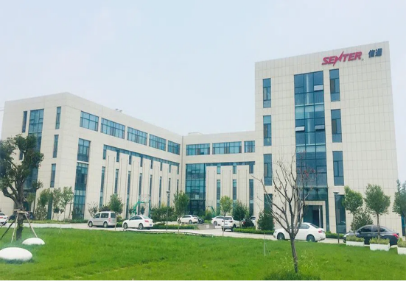
Website: https://www.senter-e.com/
Linked-in: Shandong Senter Electronic Co, Ltd
Add: No.18 Liuyishan Road,New&High-tech Area,Zibo City, Shandong Province, China
Tel: 0533-3589257
E-mail:export@senter.com.cn
About Senter

